2025-2026 Anatolian High School 9th Grade 2nd Term 1st Written Exam
Name – Surname: Class: Number:

- Read the speeches and answer the questions. (ENG.9.4.R3) (3x5=15)




Jack is a security guard. He works at a large shopping centre. He monitors the building and checks people’s IDs.

Rita is a digital marketer. She works remotely and promotes products on social media platforms.

Mike is a computer programmer. He works at an IT company. He develops software applications.
  - What is Rita’s job? ................................................................................................................................
  - Where does Jack work? ........................................................................................................................
  - What does Mike do at work?..................................................................................................................



Read the card and write 3 sentences about Martin. (ENG.9.4.W4) (3x5=15)
Name: Martin White Job: Psychologist Workplace: Clinic Activity: counsel people with emotional problems

  - .............................................................................................
  - .............................................................................................
  - .............................................................................................

C1. Read the text, look at the pictures and write the correct names. (ENG.9.4.V1) (4x3=12)


My name is Rita. In my family, everyone has a different job. My mother, Julia, is a scientist. She works in a science lab. She researches new topics and conducts experiments every day. My father, Mark, is an architect. He works in an architecture firm. He designs buildings and prepares plans for new projects. My aunt, Clara, is a journalist. She works at a news agency. She reports
1
2
news and publishes articles online. My older brother, Leo, is a photographer. He works in a photography studio. He
shoots photographs for clients. ................................. .................................



C2. Write the workplaces in the text. (4x2=8)
3
4
Workplaces
1.
2.
3.
4.

................................. .................................

D. Read the text and answer the questions. (ENG.9.5.R2) (4x4=16)

Hello, I am Oliver, and I am 15 years old. I live in a semi-detached house in a peaceful town. Downstairs, there is a sitting room and a kitchen. Upstairs, there are three bedrooms and a bathroom. In the sitting room, we have a sofa, an armchair, and a coffee table. There is also a large carpet. In the kitchen, we have a dishwasher, a cooker, and a fridge.
Every morning, I make my bed and tidy up my room. After dinner, my father washes the dishes. At the moment, my mother is preparing dinner, and my sister is reading a book in her bedroom. Home sweet home!
- What type of house does Oliver live in? ......................................................................................................
- What does Oliver do every morning? ..........................................................................................................
- What appliances are there in the kitchen? ..................................................................................................
- What is his mother doing right now? ...........................................................................................................

E. Look at the pictures. Write what the people are doing now. Use the verbs and the places given. There are extra verbs and places. (ENG.9.5.G1) (3x6=18)

- watch TV
- cook
- study
- read a book
- have dinner
- water the flowers
- living room
- bedroom
- garden
- utility room
- dining room
- bathroom

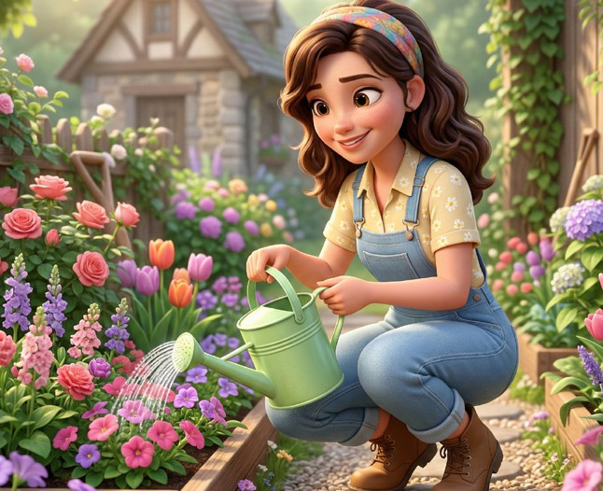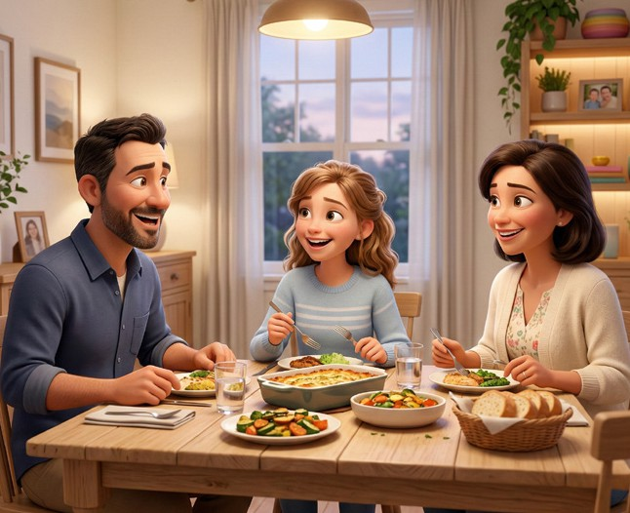
1

Rita
2

Martin
3

Sue, Lily and Tim

- ............................................................................................................................................
- ............................................................................................................................................
- ............................................................................................................................................

F. Answer the questions about yourself. (ENG.9.5.W3) (4x4=16)

- What type of house do you live in?
.............................................................................................................................
- How many rooms are there in your house?
.............................................................................................................................
- What furniture is there in your sitting room?
.............................................................................................................................
- Which room is your favourite? Why?
.............................................................................................................................

