2025-2026 Anatolian High School 9th Grade 2nd Term 1st Written Exam
Name – Surname: Class: Number:

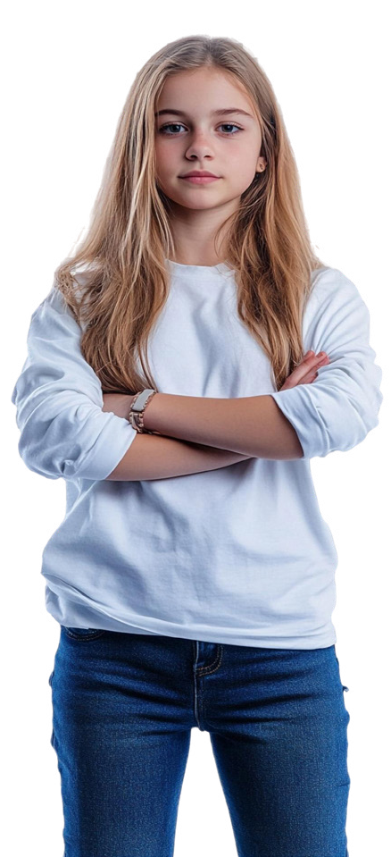
- Read the text and complete the table with the words/phrases from the text. (ENG.9.4.V1) (20pts)
Hello, I am Daisy, and I am 15 years old. I am a student. The adults in my family have very interesting careers. My father is an architect and works at an architecture firm. He designs new buildings. My mother works in a business office as a digital marketer. She organises campaigns and promotes products. My uncle is a lawyer. He works at a law firm and defends his clients. My aunt works at a news agency as a journalist. She reports important news. Finally, my older brother is a photographer. He shoots beautiful photographs in a photography studio.

Occupations  (5x1=5) | Workplaces  (5x1=5) | Work activities (5x2=10)
1.  2.  3.  4.  5. | 6.  7.  8.  9.  10. | 11.  12.  13.  14.  15.


- Read the cards and write 3 sentences about Susan. (ENG.9.4.W4) (3x5=15)

Name: Susan Forest Job: Pharmacist Workplace: Pharmacy Activity: serve customers and check prescriptions

  - ............................................................................................

  - ............................................................................................

  - ............................................................................................

- Read the advertisement and answer the questions. (ENG.9.5.R2) (4x5=20)
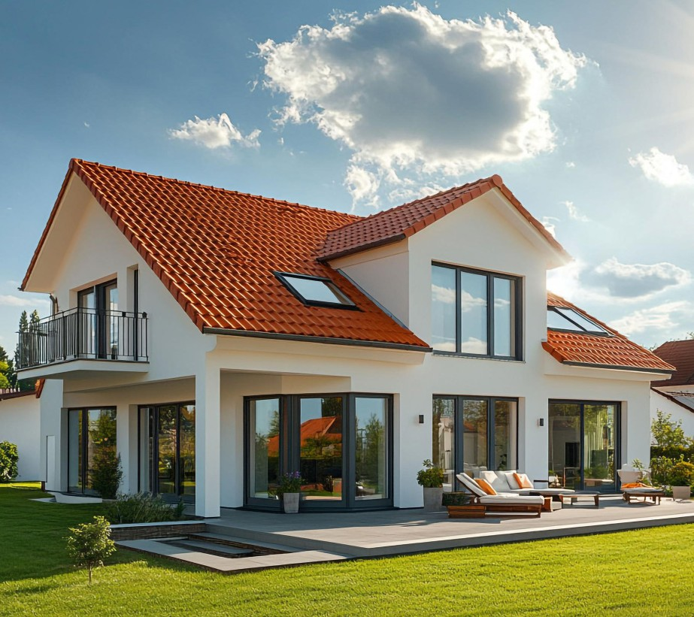

A Dream Home Awaits You!
Are you looking for a peaceful lifestyle away from the crowded city? This beautiful detached house in the countryside is perfect for you! The house is very spacious. There are two large bedrooms upstairs and a bright sitting room downstairs. The sitting room has a modern design with a soft sofa, a stylish coffee table, and an antique rug.
The modern kitchen includes a dishwasher, a freezer, and a new oven. Outside, there is a large garden where you can relax, and a garage for two cars. Make yourself at home in this lovely property!
More Info: +1234567890

  - What type of house is it? ...........................................................................................................................
  - How many bedrooms are there upstairs? .................................................................................................
  - Where is the sitting room? ..........................................................................................................................
  - What appliances are there in the kitchen? .................................................................................................

- Read the text and answer the questions. (ENG.9.4.R3) (4x5=20)
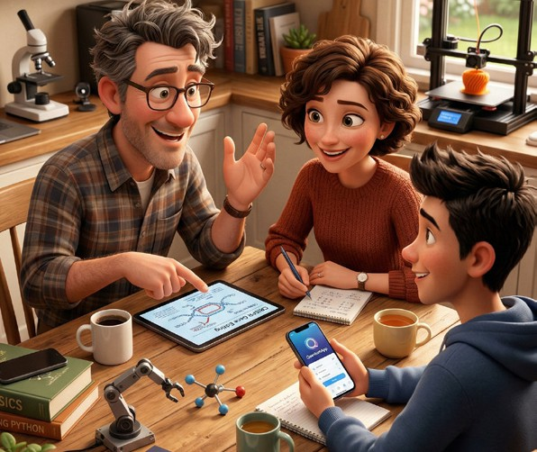
The Miller family is interested in science and technology. The father, Paul, is a scientist. He works in a science lab and makes new discoveries. He spends most of his day conducting experiments. The mother, Emily, is
an accountant. She works in an accounting firm. She advises clients on finances and prepares financial reports. Their son, David, is a computer programmer at an IT company. He develops mobile applications and solves software problems. At weekends, they discuss new technological developments.
- What is Emily’s job? ................................................................................................................................
- Where does David work? ........................................................................................................................
- What does Paul do at the science lab? ....................................................................................................
- What is the Miller family’s weekend routine? ..........................................................................................

- Look at the pictures. Write what the people are doing now. Use the verbs and the places given. There are extra verbs and places. (ENG.9.5.G1) (5x5=25)

- make the bed
- brush teeth
- watch TV
- cook
- study
- read a book
- have breakfast
- living room
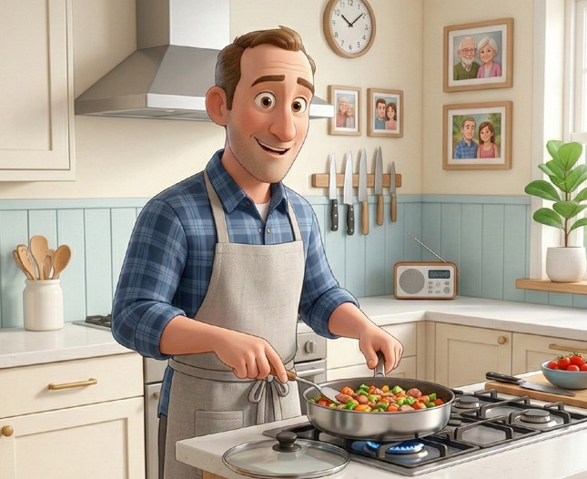
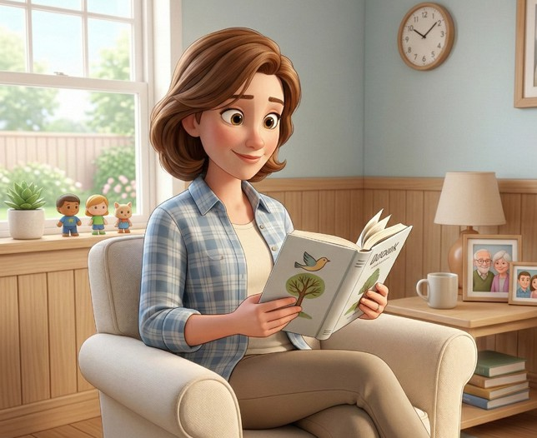
- bedroom
1

Andy
2

Sophia
- garden
- utility room
- dining room
- bathroom
- kitchen

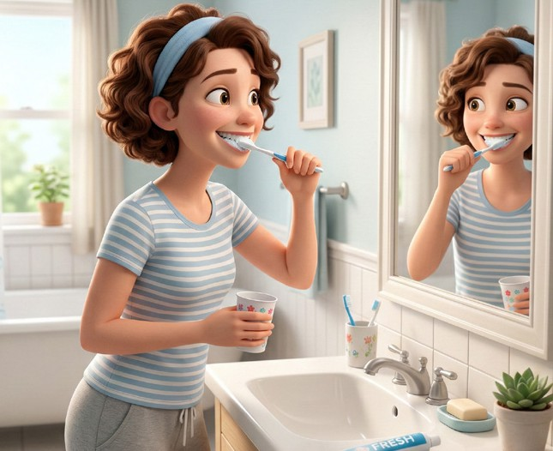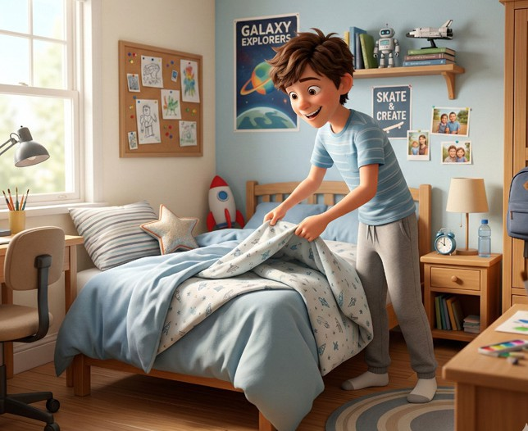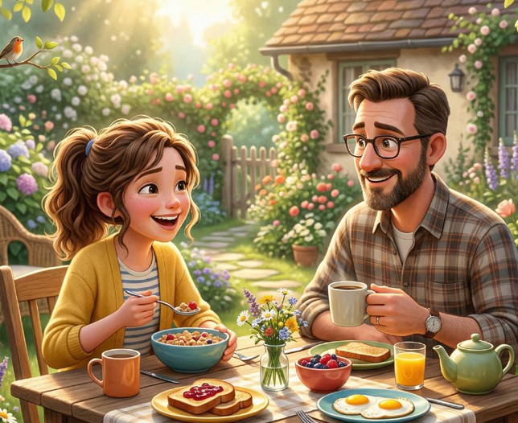
3

Rose
4

Philip
5

Amy and Tom

  - ............................................................................................................................................
  - ............................................................................................................................................
  - ............................................................................................................................................
  - ............................................................................................................................................
  - ............................................................................................................................................

