


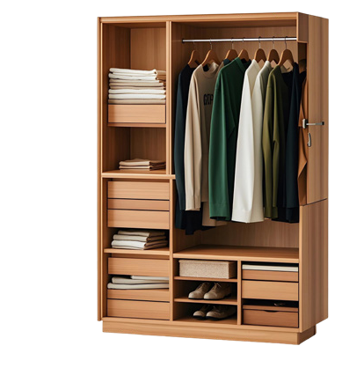

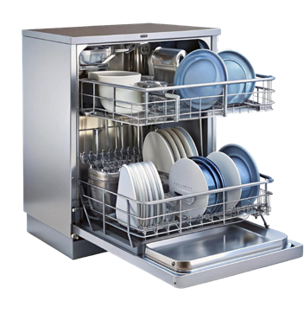
2025-2026 9th Grades 2nd Term 1st Listening Exam
5
8
9
10
Name – Surname: Class: Number:

Listening 1 - Listen to the recording and complete the table. (5x10=50)

Write 2 (two) Family Members

- ................................

- ................................

Write 2 (two) Occupations

- ................................

- ................................
Write 1 (one)
Workplace
5. ................................

Listening 2 - Listen to the recording. Put a tick () next to the pictures you hear, and a cross () next to the pictures you do not hear. (10x5=50)







1
2
3
4
6
7

