2025-2026 Secondary School 5th Grade 2nd Term 1st Written Exam
Name – Surname: Class: Number:

- Read the travel blog and write the name of the correct place. (ENG.5.5.R2.) (4x4=16)
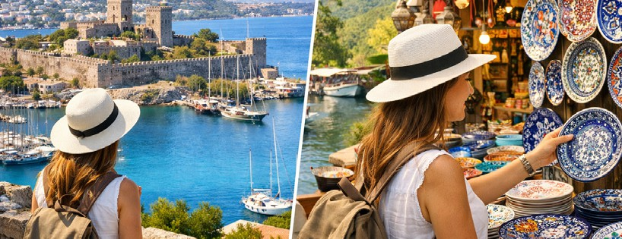
WELCOME TO MY TRAVEL BLOG @TravelWithCeren

#Travel #Bodrum #Akyaka
Hello, followers! Today, I am in Bodrum. It is a very famous and crowded town. There are many ancient sites and a historical castle here. I usually take a tour of the castle in the mornings. In the afternoons, I go to Akyaka. Akyaka is smaller than Bodrum, but it is very peaceful. There is a great street fair in Akyaka. I love buying handmade plates there!
Published: March 4, 2026

- This place is famous and crowded. .......................
- This place has a street fair. ..........................
- This place has a historical castle. ........................
- This place is more peaceful. ..........................

- Read the dialogue and answer the questions. (ENG.5.5.R3.) (3x5=15) Janet: Welcome, Sara. Come in, please. Our new flat is ready!
Sara: What a lovely flat!
Janet: This is our sitting room. We relax and watch TV here in the evenings.
Sara: Oh, this wide sofa is very comfortable.
Janet: Yes, it is. That armchair in the corner is more comfortable than the sofa. It is my father's. Now, let's go to the kitchen. It is the heart of our home!
Sara: It looks nice. By the way, we need an atlas for our homework. Where is the nearest library?
Janet: Oh, there isn't a library in our neighbourhood. I usually use our school library.
- What do Janet and her family do in the sitting room? .............................................................................
- What type of house does Janet live in? ..................................................................................................

- Where does Janet usually study? ...........................................................................................................

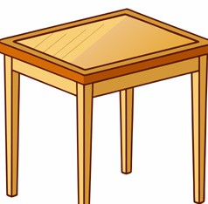
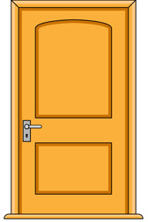
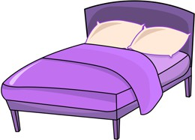


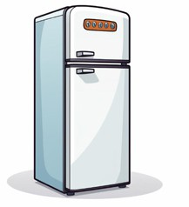

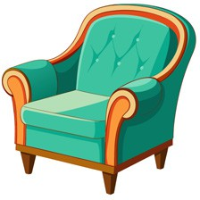

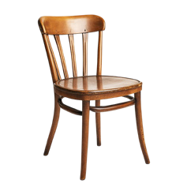
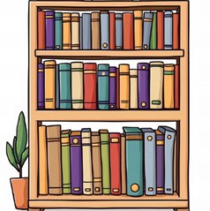
- Look at the pictures. Put a tick () next to the words you see, and a cross () next to the words you cannot see. (ENG.5.5.V1) (15x1=15)
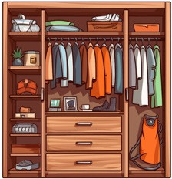

1. fridge |  | 2. bookcase |  | 3. oven |  | 4. bath |  | 5. spoon
6. castle |  | 7. table |  | 8. bed |  | 9. fork |  | 10. wardrobe
11. plate |  | 12. armchair |  | 13.dishwasher |  | 14. sofa |  | 15. tower

- Complete the sentences with the correct form of the adjectives. (ENG.5.5.G1.) (5x3=15)
  - A city is (crowded) than a quiet town.
  - A castle is usually (large) than a museum.
  - The sitting room is (bright) than the corridor.
  - The coast is (peaceful) than the town square.
  - A balcony is (small) than a terrace.

- Look at the pictures and write three sentences. Use “There is” or “There are”. Use the words in the box. (ENG.5.5.W3) (3x5=15)

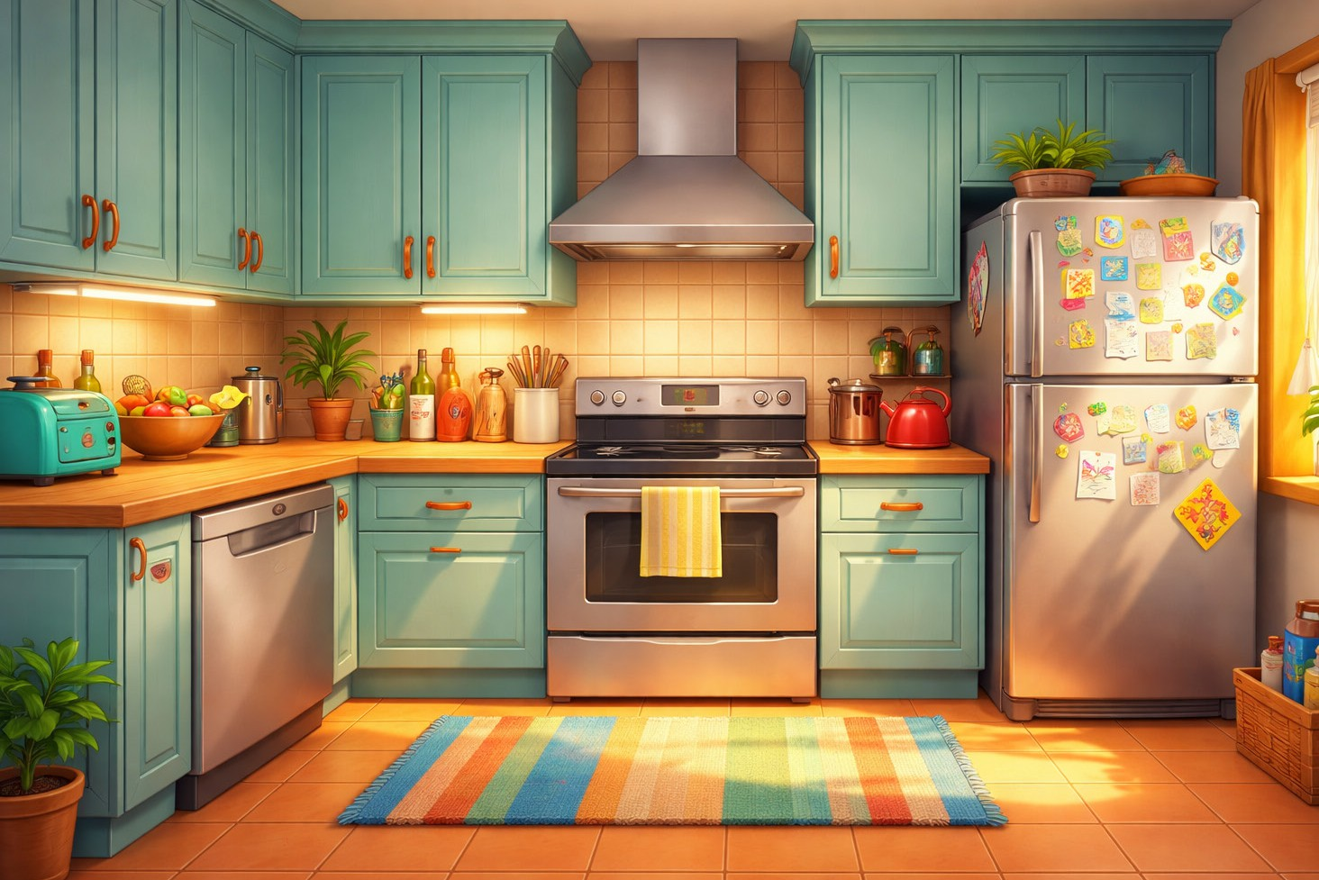
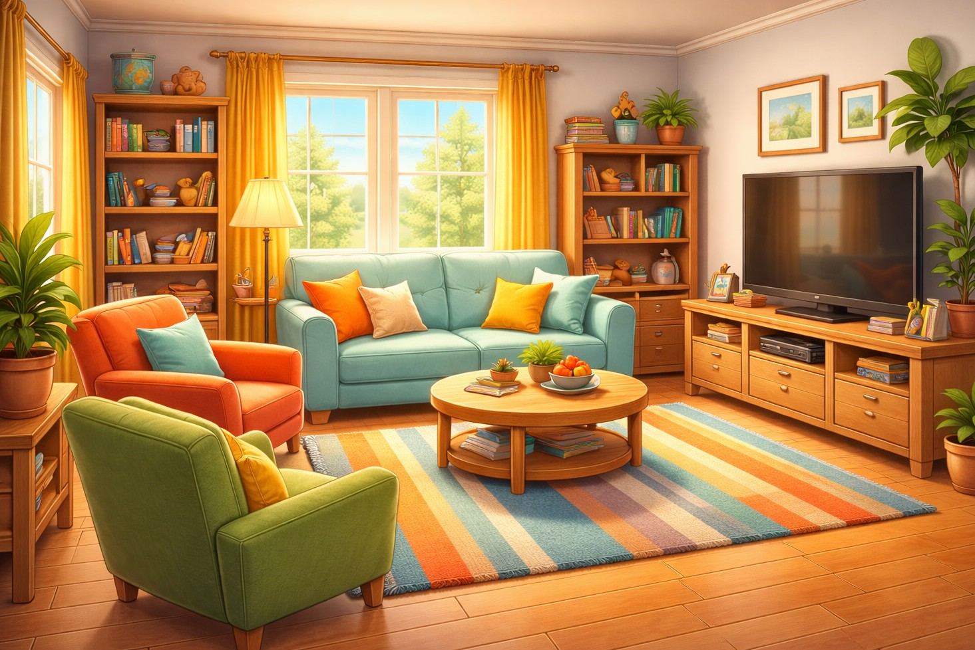
Living room
Kitchen
oven pillow bath bookcase
armchair
fridge sofa bed chair
dishwasher

  - ...............................................................................................................

  - ...............................................................................................................

  - ...............................................................................................................

- Put the words in the correct boxes. (ENG.5.6.V1.) (12x2=24)

butter -- fruit juice -- grilled chicken -- flour -- smoothie -- apple tart -- tuna salad

soda water -- cheesecake -- cake -- risotto -- oil

Ingredients

- ................................
- ................................
- ................................

Drinks

- ................................
- ................................
- ................................

Desserts

- ................................
- ................................
- ................................

Main Dishes

- ................................
- ................................
- ................................

