2025-2026 Secondary School 5th Grade 2nd Term 1st Written Exam
Name – Surname: Class: Number:

- Read the news and complete the activities. (ENG.5.5.R2.) (7x3=21)
Your Local News Source
TOWN NEWS
Tuesday, April 14, 2026
BREAKING NEWS
Weekend News from Riverside Town
This weekend, our town is full of activities. The new sports centre opened near the coast last week. It is more modern than the old gym, and Many children go to sports classes there every day.
Next to the sports centre there is a beautiful park. Families walk and cycle there. Many visitors take
photographs because the park has colourful flowers and a small lake.
You can visit the city museum in the town square. It is famous for its ancient objects and local history. There is also a new art gallery near the museum.
Don’t miss the street fair on Sunday! There are local food stalls, music shows, and fun activities.
  - Write four places in the town:

a. ..................................... b. ..................................... c. ..................................... d. ..................................

  - Write three activities you can do at the park:

a. ............................................... b. ............................................... c. ...............................................

- Look at the picture. Imagine that this is your house. Use “There is” or “There are” and write four sentences. (ENG.5.5.W4.) (4x6=24)
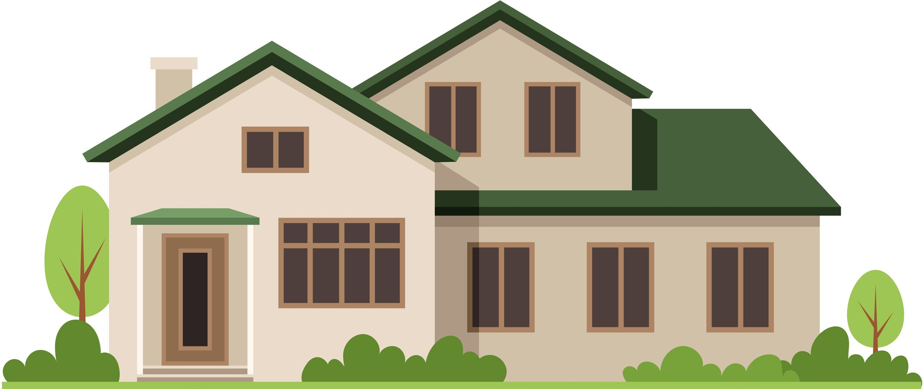
Dining room
Bathroom
Garden
Kitchen
dishwasher fridge oven
Living Room
wide sofa armchair lamp
Bedroom 1 bed wardrobe bookcase
Bedroom 2
big bed wardrobe

  - ...............................................................................................................

  - ...............................................................................................................

  - ...............................................................................................................

  - ...............................................................................................................

- Put the words in the correct boxes. (ENG.5.5.V1.) (20x1=20)
oven -- library -- bed -- balcony -- sofa -- art gallery -- bathroom -- fridge -- wardrobe -- gym -- plate bedroom -- armchair -- mosque -- knife -- dining room -- dishwasher -- garage -- museum -- bookcase

Parts of a House
- ................................
- ................................
- ................................
- ................................
- ................................

Places in a Town
- ................................
- ................................
- ................................
- ................................
- ................................

Furniture
- ................................
- ................................
- ................................
- ................................
- ................................

Kitchen Items
- ................................
- ................................
- ................................
- ................................
- ................................

- Complete the sentences with the correct form of the adjectives. (ENG.5.5.G1.) (5x3=15)
  - A city is (crowded) than a quiet town.
  - A castle is usually (large) than a museum.
  - The sitting room is (bright) than the corridor.
  - The coast is (peaceful) than the town square.
  - A balcony is (small) than a terrace.

- Read the brochure and answer the questions. (ENG.5.5.R3.) (4x5=20)

This flat is close to the sports centre and the shop. It is in a modern building with a lift.

Inside, there are two bedrooms, one bathroom, and a large living room. The living room has a comfortable sofa and a wooden bookcase.
The kitchen has a fridge, an oven, and a dishwasher.
Outside, there is a balcony. The balcony is perfect for quiet mornings.

  - How many bedrooms are there in the flat? ..............................................................................................
  - What appliances are in the kitchen? ........................................................................................................

  - Which places are close to the flat? ..........................................................................................................

  - Is there a garden outside the flat? ...........................................................................................................

