2025-2026 Secondary School 5th Grade 2nd Term 1st Written Exam
Name – Surname: Class: Number:

- Read quickly and put the words from the text into the correct columns. (ENG.5.5.R2.) (9x2=18)

Good morning, everyone! Today, I want to talk about my dream house. I don't want to live in a skyscraper or a big flat. My dream house is a tiny house in nature! It is made of wood. It is smaller than a regular house, but it is very eco- friendly. Inside, there is a small kitchen, a bathroom, and a cosy bedroom. The sitting room has got a comfortable sofa, an armchair and a wide bookcase.
I want to sit outside on my terrace, read a book, and feel peaceful.
Furniture:
•
•
•
Parts of the house:
•
•
•
Types of the house:
•
•
•

- Look at the pictures. Put a tick () next to the words you see, and a cross () next to the words you cannot see. (ENG.5.5.V1) (15x2=30)
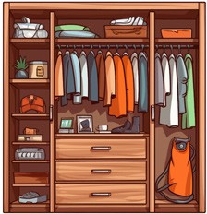
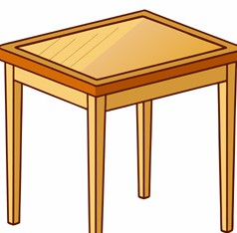
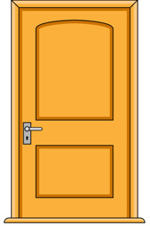
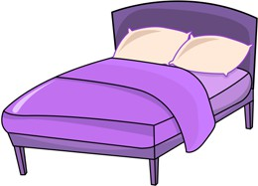
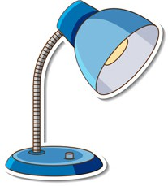
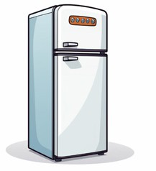

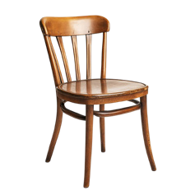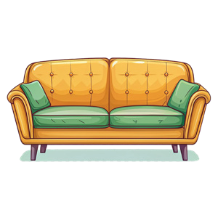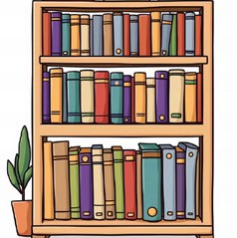

1. fridge |  | 2. bookcase |  | 3. oven |  | 4. bath |  | 5. spoon
6. castle |  | 7. table |  | 8. bed |  | 9. fork |  | 10. wardrobe
11. plate |  | 12. armchair |  | 13.dishwasher |  | 14. sofa |  | 15. tower

- Complete the sentences with the correct form of the adjectives. (ENG.5.5.G1.) (5x4=20)

  - A town is (peaceful) than a city.
  - A flat is (small) than a house.
  - A skyscraper is (tall) than a tower.
  - An armchair is (comfortable) than a chair.
  - My neighbourhood is (quiet) than the city centre.

- Look at the pictures and write four sentences. Use There is / There are. Use the words in the box. (ENG.5.5.W3) (4x4=16)
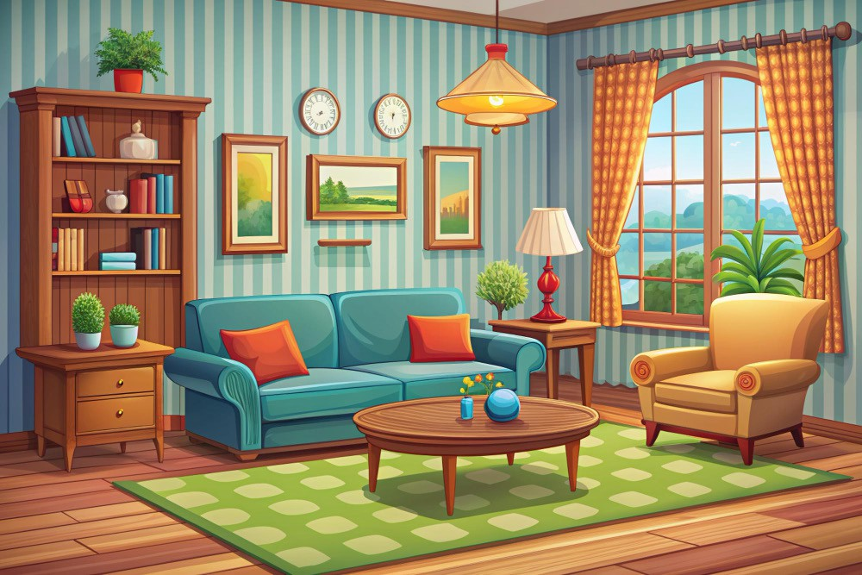
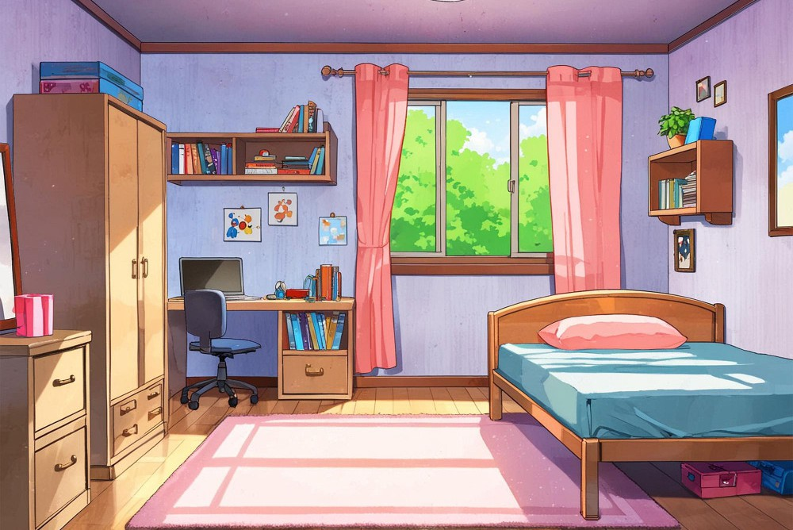
Living Room
Bedroom

  - ...............................................................................................................
shelf pillow bath bookcase
armchair
fridge sofa bed chair
dishwasher

  - ...............................................................................................................

  - ...............................................................................................................

  - ...............................................................................................................

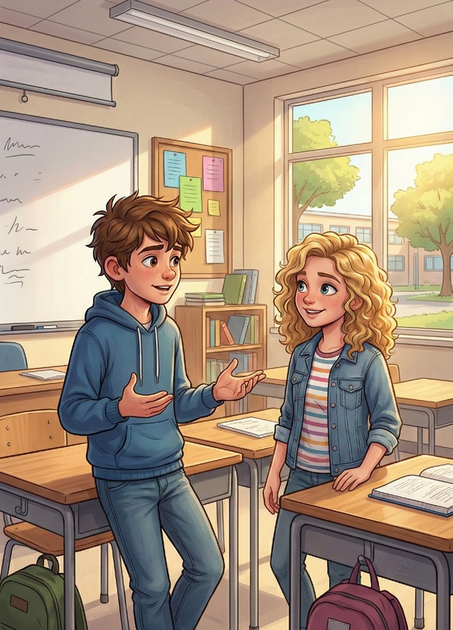
- Read the dialogue and answer the questions. (ENG.5.5.R3.) (4x4=16) Emma: Hi Leo! Do you like your new neighbourhood?
Leo: Yes, I do. It is more peaceful than my old one.
Emma: Really? What places are there around your house? Leo: There is a sports centre, a square, and a big art gallery. Emma: Wow! That sounds great. Is there a gym?
Leo: Yes, there is. I cycle there every weekend.
Emma: My neighbourhood is more crowded, but there are many shops and cafés.
Leo: Is there a museum?
Emma: Yes, there is a modern museum near the castle.
Leo: That’s interesting! My house is bigger than our old flat. There is
a wide balcony and a wooden roof.
Emma: Nice! I live in a small flat, but it is close to everything.

- Who lives in a flat? ...................................................................................................................................
- Which neighbourhood is more peaceful? .................................................................................................

- What places are there around Leo’s new house? ....................................................................................

- Is there a museum in Emma’s neighbourhood? .......................................................................................

