2025-2026 School 5th Grades 2nd Term 1st Listening Exam
Name – Surname: Class: Number:

Listening 1 - Listen to the recording and number the pictures from 1 to 5. (Theme 4)










A
B
C
D
E

Listening 2 - Listen to the speech and tick () 5 (five) words or phrases you hear. (Theme 4)

1. 4. 7.
brushing his teeth
sleeping in a tent
fishing

2. 5. 8.
swimming in the sea
playing with a ball
walking in the forest

3. 6. 9.
taking a photo
riding a bicycle
playing the guitar

Listening 3 - Listen to the conversation and put the sentences in the correct order. (Theme 4)

a.
Yes! Your father is cleaning the barbecue in the garden.

b.
I love barbecues! I am wearing my new blue T-shirt.

c.
1 Harry, wake up! It is the day of the party.

d.
She is in the kitchen. She is preparing the salad for the guests.

e.
8 Okay, Mum. I am going to the bathroom now.

f.
Good morning, Mum. Everyone is awake, aren’t they?

g.
4 Okay, I am getting up. What is Diana doing?

h.
Great. But first, brush your teeth and wash your face.

Listening 4 - Listen to the conversation and match the family member to the activity. (Theme 4)





1. Emma 2. Father
3. Mother
4. David

- Cooking lunch
- Feeding the cat
- Washing the car
- Tidying up / Asking for help

Listening 5 - Listen to the recording and complete the blanks. (Theme 5)


Hello everyone! Welcome to Maple Town. Today, I am your guide.
Our town square is very famous and crowded on weekends. There is an ancient (1) near the square. Many tourists take
photographs there.
On the left corner, there is a modern (2) There are
many colourful paintings inside. The (3) is older than
the art gallery, but the gallery is more popular with teenagers.
If you walk along the coast, you can see a quiet (4) ................................ .
Families cycle there every Sunday. Some people fish near the water.
The (5) is newer than the gym on King Street. It is bigger and more modern. Many local people attend events in the big hall next to it.
Maple Town is small, but it is more peaceful than many big cities.

Listening 6 - Listen to the speech and tick () or cross () according to the recording. (Theme 5)




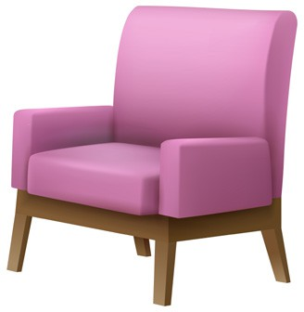








1
2
3
4
5
6
7
8
9
10

Listening 7 - Listen to Julia’s talk and number the pictures from 1 to 5 in the order you hear them. (Theme 5)


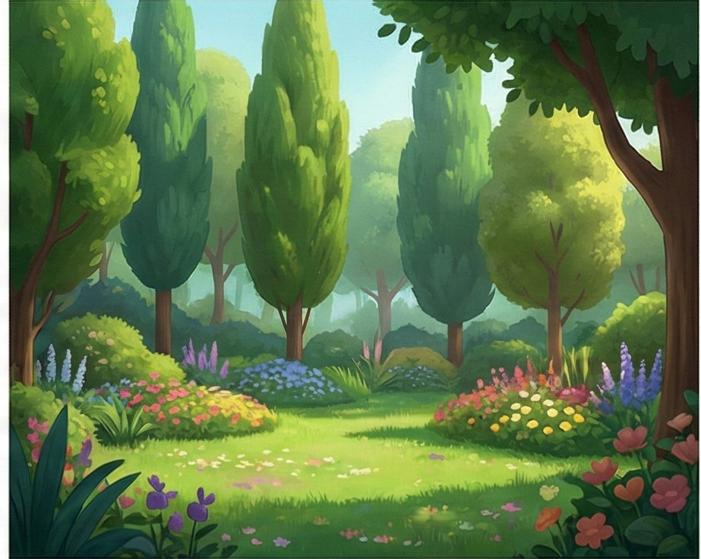




A
B
C
D
E

Listening 8 - Listen to the speech and tick ( ) 5 (five) places you hear. (Theme 5)


1. 6.
mosque
museum

2. 7.
tower
school

3. 8
playground
castle

4. 9.
library
art gallery

5. 10.
shoe shop
forest

