2025-2026 Anatolian High School 9th Grade 2nd Term 2nd Written Exam
Name – Surname: Class: Number:

- Read Rita’s diary and answer the questions. (ENG.9.5.R3) (4x3=12)


Hello, I’m Rita. Today is a busy Saturday at home. Our detached house usually feels quiet in the mornings, but everyone is busy now. Mum is cleaning the kitchen, and Dad is vacuuming the carpet in the sitting room. My little brother, Tom is brushing his teeth in the bathroom. I am tidying up my bedroom because my cousins are coming in the afternoon. My bedroom is upstairs, next to my parents’ room. It has a bed, a wardrobe, a bedside
table, and blue curtains. I like Saturdays because we do a lot of things together. Home sweet home!
  - What is Tom doing now?
............................................................................
  - Why is Rita tidying up the bedroom?
............................................................................

  - Where is Rita’s bedroom?
............................................................................
  - What is there in Rita’s bedroom?
...........................................................................

2A. Read the text and complete the festival card. (ENG.9.6.V1) (6x1=6)

Today, I am visiting the City Food Festival with my friend. The festival takes place in the main square every spring. There are many local and international food stalls. A Turkish vendor is making lahmacun, and two students are tasting spicy tacos at the Mexican stall. Near the stage, a chef is cooking a giant omelette in a large pan. It smells delicious! I usually prefer savoury food, but today I am trying some orange cake. Visitors are tasting delicious meals, taking photos, and asking questions about the ingredients. Food festivals are wonderful events because people learn about different cultures.

- Festival name: ...................................
- Place: ................................................
- Time / Season: ..................................
- A Turkish dish: ...................................
- A Mexican dish: .................................
- A dessert: ..........................................

2B. Read the text and answer the questions. (ENG.9.6.R3) (4x3=12)
- What kinds of food stalls are there at the festival? ..............................................................................
- What is the Turkish vendor making? ..............................................................................
- What are two students tasting? ..............................................................................
- Why are food festivals wonderful events? ..............................................................................

2C. Complete with the correct question words: Why, Where, What, and When. (ENG.9.6.G1) (4x2=8)

- A: does the festival take place?
B: In the main square.
- A: does the festival take place?
B: Every spring.
- A: is the Turkish vendor making?
B: Lahmacun.
- A: are food festivals wonderful?
B: Because people learn about different cultures.

Read the text and complete the information table using phrases. (ENG.9.7.R2) (5x2=10)


Great white sharks live in oceans. They are powerful hunters, but they are endangered in many places. Overfishing is one of the biggest threats to them. Some people hunt sharks for their body parts. In the past, there were more sharks in some coastal areas. People should protect ocean habitats and stop
overfishing. These sharks are important for the
balance of marine life.
Animal: (1) ....................................................
Habitat: (2) ...................................................
Main threats: (3) ..........................................
Past situation: (4) .........................................
Protection advice: (5) ....................................


Read the text and complete it with the words from the box. One is extra. (ENG.9.7.G1) (6x2=12)
- am - is - are - was - were - should - shouldn’t
A century ago, there (1) ........................... over 100,000 tigers. Their habitat (2) very
large in the past, but it (3) smaller today. Now, a tiger hunts for food in a smaller
area. Tigers (4) at risk today because of habitat loss and illegal hunting. We
(5) ........................... stop illegal hunting. We (6) destroy their natural habitats.

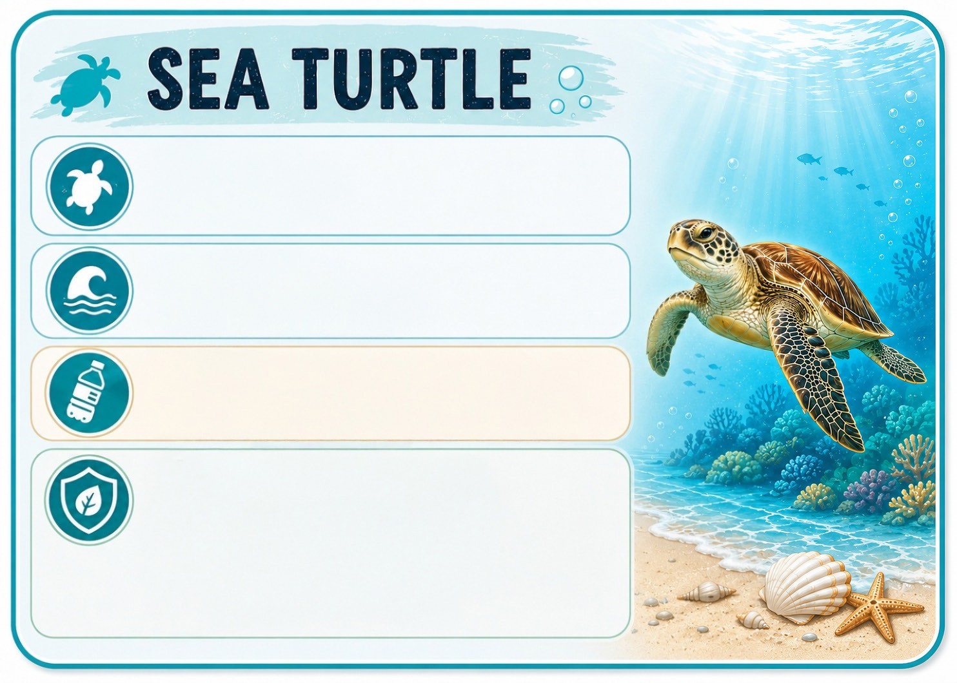
- Look at the card and write three sentences about the animal. (ENG.9.7.W3) (3x5=15)

Animal: Sea turtle

Habitat: Oceans, beaches
Cause of Endangerment:
Marine pollution
Actions for Protection:
☑ Stop pollution
☑ Reduce plastic use
☑ Protect ocean habitats

  - .........................................................................................

  - .........................................................................................

  - .........................................................................................

Read the text and answer the questions. (ENG.9.8.R3) (3x5=15)


Science fantasy films usually combine space, technology, and imagination. In these films, heroes often travel to strange planets and meet intelligent robots or aliens. My new film idea is called “The Virtual Planet”. The story will take place in 2090. A young inventor will discover a digital world inside a computer system. She won’t fight the robots at first because they want to help her. Later, an alien signal will change everything. I think audiences will love the film because it has mystery and adventure.

  - What is the title of the new science fantasy film idea?

......................................................................................

  - When will the story of “The Virtual Planet” take place?

......................................................................................

  - Why does the writer think audiences will love the film?

......................................................................................

- Write the words under the correct categories in the table. (ENG.9.8.V1) (10x1=10)
virtual reality - satellite - audience - adventure - ocean - director
- artificial intelligence - desert - horror - spacecraft

Film Types | Digital Concepts | Film & Cinema Terms | Space | Habitats
1 | 3 | 5 | 7 | 9
2 | 4 | 6 | 8 | 10

