2025-2026 Anatolian High School 9th Grade 2nd Term 2nd Written Exam
Name – Surname: Class: Number:

- Read the text and answer the questions. (ENG.9.4.R2) (4x5=20pts)


The Green family has different work routines. Mrs. Green is a businessperson. She runs a large company and is in charge of the office. She must manage fifty employees. Mr. Green is a lawyer. He works in a busy law firm. He defends clients every day. Their daughter, Clara, is a photographer. She shoots beautiful photographs
in her photography studio. Clara doesn’t work on Saturdays and Sundays. She rests and researches new photography styles.

  - Where does Mr. Green work?
.........................................................................................
  - What is Clara’s job?
.........................................................................................
  - Who runs a large company?
.........................................................................................
  - What does Clara do at the weekends?
.........................................................................................

- Read the dialogue and mark the sentences as T (True), F (False) or NM (Not Mentioned). (ENG.9.6.R3) (6x2=12pts)

Reporter: Hello! We are at the Taste of Adana Festival today. Is this a local or an international event?
Organiser: It is a local festival, but many tourists are visiting it this year.
Reporter: Which dish is the most famous here? Organiser: Adana kebab, of course. Chefs mix minced lamb and beef with red pepper and herbs. Then they grill it over a charcoal fire.
Reporter: How do they serve it?
Organiser: They usually serve it with onion salad and grilled vegetables. Today, some chefs are serving it in flatbread for visitors.
Reporter: What are the visitors doing now? Organiser: They are watching cooking shows, tasting dishes, and joining workshops.

. 1. The festival takes place every October.

. 2. The reporter is at a food event today.

. 3. The festival is an international festival.

. 4. Adana kebab is the most famous dish at the event.

. 5. Visitors are buying tickets for the workshops.

. 6. They cook Adana kebab in an oven.

- Complete the text with the Simple Present or Present Progressive form of the verbs in parentheses. (ENG.9.6.G1) (5x3=15pts)

Today, Oliver (1) ............................... (visit) the City Food Festival with his friend. The festival (2) ...............................

(take) place in the main square every spring. There are many international food stalls. A Turkish vendor

(3) ............................... (make) lahmacun right now. Two students (4) (taste) spicy tacos at the

Mexican stall. Oliver usually (5) (prefer) savoury food, but today he is trying some orange cake.


4A. Read the dialogue and complete the blanks with the correct words from the text. (ENG.9.7.V1) (5x1=5)

Ecologist: Chimpanzees are endangered. They live in rainforests, but their habitats are getting smaller. People cut down trees, and this causes habitat loss.
Sharon: Were rainforests safer in the past?
Ecologist: Yes, they were larger and quieter. There were more food sources for chimpanzees.
Sharon: How can we help chimpanzees?
Ecologist: We should protect rainforests, support volunteers, and stop illegal hunting. Chimpanzees need safe places to survive.

- the natural homes of an animals:
.........................................
- in danger of disappearing:
.........................................
- hunting animals against the law:
.........................................
- people who help for free:
.........................................
- losing an animal’s home:
.........................................

4B. Read the dialogue and answer the questions. (ENG.9.7.R2) (3x5=15)
- Why are chimpanzees endangered? .....................................................................................................
- What should people do to help chimpanzees? ......................................................................................
- What were rainforests like in the past? .................................................................................................

4C. Write the correct corresponding question for each answer. (ENG.9.7.G1) (2x5=10)
- Q: ? A: They live in rainforests.
- Q: ? A: Because people cut down trees.

- Read the text and answer the questions. (ENG.9.8.R3) (4x5=20)

  - What do science fantasy films usually combine?
Science fantasy films usually combine space, technology, and imagination. In these films, heroes often travel to strange planets and meet intelligent robots or aliens. My new film idea is called “The Virtual Planet”. The story will take place in 2090. A young inventor will discover a digital world inside a computer system. She won’t fight the robots at first because they want to help her. Later, an alien signal will change everything. I think audiences will love the film because it has mystery and adventure.
......................................................................................
  - What is the title of the new science fantasy film idea?
......................................................................................
  - When will the story of “The Virtual Planet” take place?
......................................................................................
  - Why does the writer think audiences will love the film?
......................................................................................

- Use the information card and write three sentences about Martin’s dream film. Use will and/or won’t.
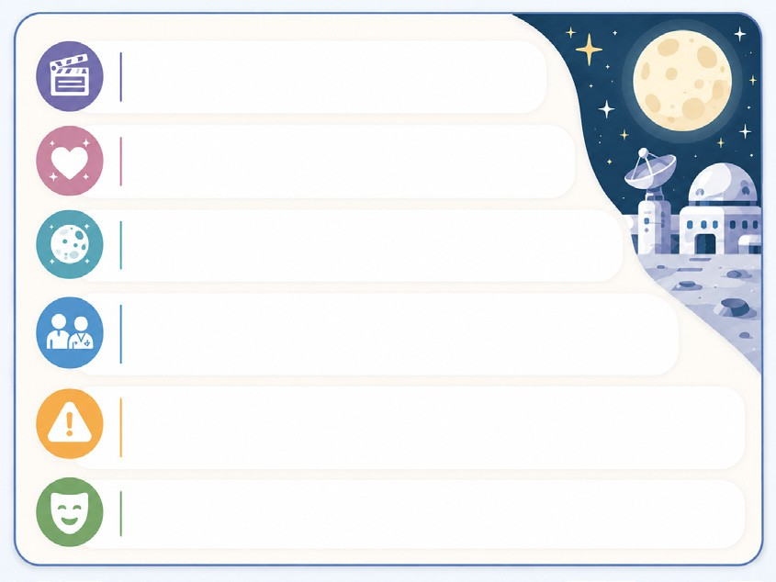
(ENG.9.8.W3) (3x5=15)

Film title: On the Moon
Genre: Romantic comedy
Setting: a station on the Moon in 2075
Main characters: A young engineer and a space doctor Problem: They miss the last spaceship to Earth
Prediction: funny and emotional

  - ........................................................................................................

  - ........................................................................................................

  - ........................................................................................................

