2025-2026 Anatolian High School 9th Grade 2nd Term 2nd Written Exam
Name – Surname: Class: Number:

1A. Read the dialogue and write people’s jobs. (ENG.9.4.V1) (4x1=4)

Ece: Hi, Mert. I need examples for my family life project. What does your father do? Mert: He is a photographer. He works in a photography studio and shoots photos. Ece: That’s great! What about your mother?
- Ece’s aunt:
.................................
- Mert’s father:
.................................
- Mert’s brother:
.................................
- Mert’s mother:
.................................
Mert: She is a bank clerk. She works at a bank and helps customers.
Ece: Does anyone in your family work online?
Mert: Yes, my brother is a content creator. He publishes videos on Youtube.
Ece: Interesting! My aunt is a scientist. She works in a science lab.
Mert: Then we both have good examples for the project.

1B. Read the dialogue again and answer the questions. (ENG.9.4.R3) (4x2=8)
- Where does Mert’s father work? .........................................................................................
- What does Mert’s mother do at the bank? ..........................................................................
- Who publishes videos online? ............................................................................................
- Where does Ece’s aunt work? ............................................................................................

1C. Complete the questions with “is, does, or do”. (ENG.9.4.G1) (4x2=8)

- What Ece and Mert have for the project?
- What your mother’s job?
- Where your brother work?
4 your father a content creator?

Read the text and complete the information card. (ENG.9.6.R2) (10x1=10)


We are at the City Food Festival today. There are many different international dishes to try. Look at that busy stall over there! The vendor is serving a hot Indian curry. Curry is a traditional dish made with a lot of spices. It can be very spicy. The chef is cooking chicken, sweetcorn, and spinach in a creamy sauce. He stirs it carefully so it does not burn. He is serving it with a large bowl of rice.
What a delicious meal!
Event: (1) ...........................................
Type of food: (2) ...............................
Dish name: (3) ..................................
Cuisine: (4) .......................................
Ingredients: (5) ..........................., (6) ,
(7) ..........................., (8) ...........................
Tastes: (9) ........................... and (10) ...........................

Look at the festival card and write four sentences about the event. (ENG.9.6.W4) (4x5=20)


Event: Italian Food Festival
City: Ankara
Place: Gençlik Park
Time: Every spring
Food: pasta, pizza, tiramisu Activities now: watching cooking shows, tasting dishes, taking photos

  - .....................................................................................

  - .....................................................................................

  - ....................................................................................

  - .....................................................................................

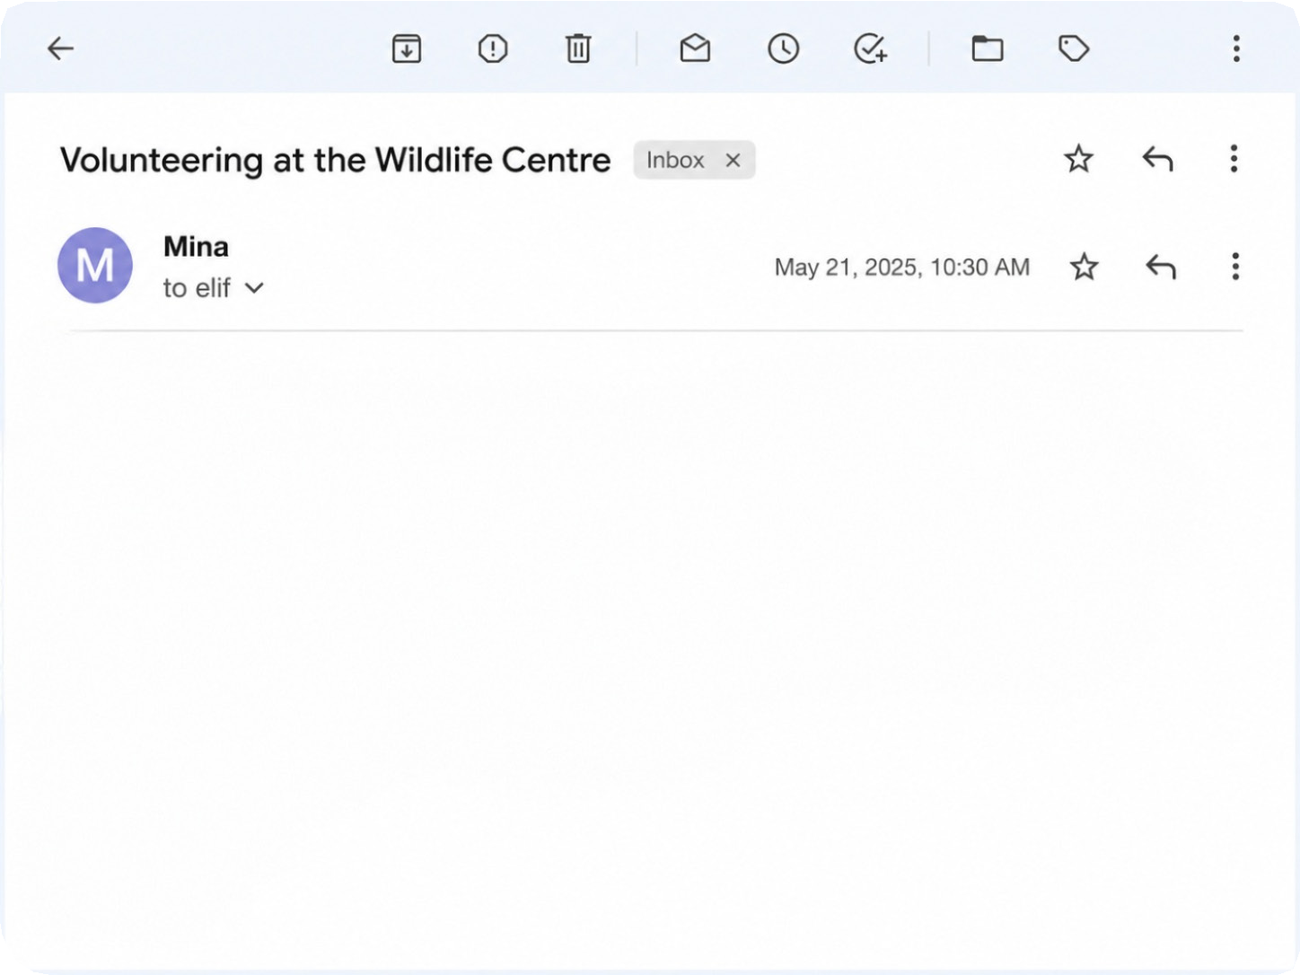
Read the email and answer the questions. (ENG.9.7.R3) (4x5=20)

Hi Elif,
I am working as a volunteer at a wildlife centre this month. We care for injured dolphins and sea turtles. Some turtles eat plastic because it looks like jellyfish. The centre teaches visitors about marine pollution and overfishing.
We should reduce plastic use and clean beaches to protect ocean wildlife. Every little bit helps.
Best wishes, Mina

  - Where is Mina working?

......................................................................................
  - Which animals does the centre care for?

......................................................................................
  - Why do some turtles eat plastic?

......................................................................................
  - What should people do to protect ocean wildlife?

......................................................................................

Read the text and complete the sentences using the bold words / phrases. (ENG.9.7.V1) (5x2=10)


  - We can money to wildlife organizations to
Asian elephants live in jungles and woodlands. A long time ago, their habitats were much larger. Today, habitat loss threatens these animals. People cut down trees to build roads, so there is not enough food for the elephants. They hide in smaller forest areas now. We should prevent deforestation to save them. If we donate to wildlife charities, we
can support their survival.
help animals.
  - Asian elephants’ natural homes are ............................................
............................
  - Elephants are losing their homes; this problem is called
................................ .
  - We should people from cutting down trees.
  - Frightened animals usually behind big trees.

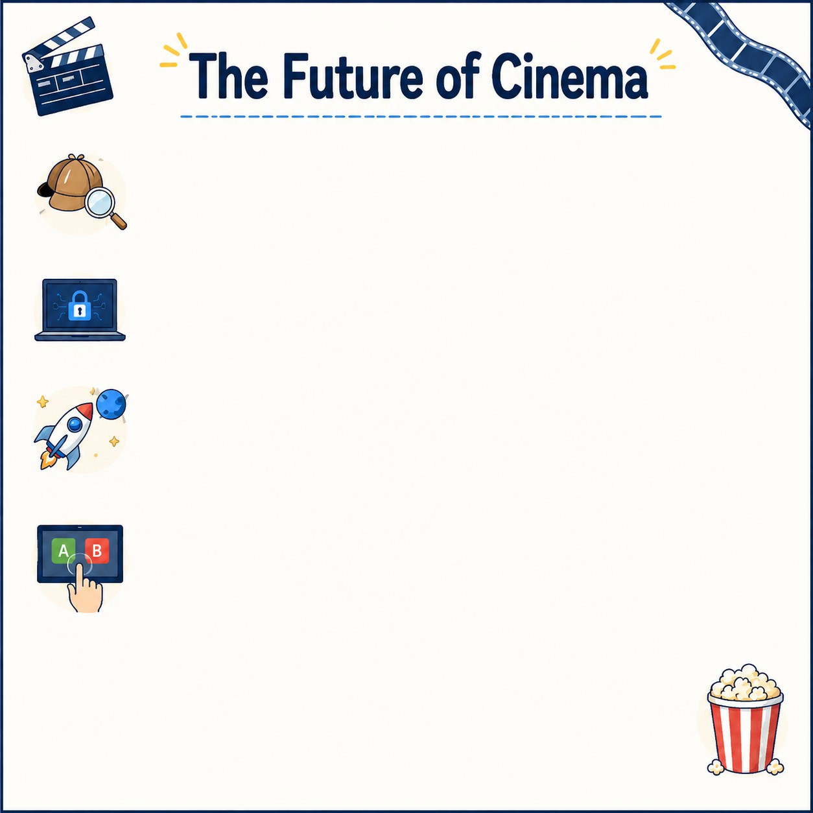
Read the social media post and answer the questions. (ENG.9.8.R2) (4x5=20)

Hello film fans! Today, let’s talk about the future of film genres. I think traditional detective films will disappear. Instead, we will watch cyber-crime mysteries. Also, romantic comedies will probably take place in space! Can you imagine a love story during a space exploration mission? Furthermore, filmmakers will invent interactive movies. Audiences will choose the ending. This interactive technology will be a breath of fresh air. Leave a comment below: What will be your favourite
genre in 2050?

  - What will people watch instead of traditional
detective films?

......................................................................................

  - Where will romantic comedies probably take place?

......................................................................................

  - What will filmmakers invent?

......................................................................................

  - Who will choose the ending in interactive movies?

......................................................................................

