2025-2026 Anatolian High School 9th Grade 2nd Term 2nd Written Exam
Name – Surname: Class: Number:

1A. Read the text and write the words / phrases in bold into the correct categories. (ENG.9.5.V1) (6x1=6)

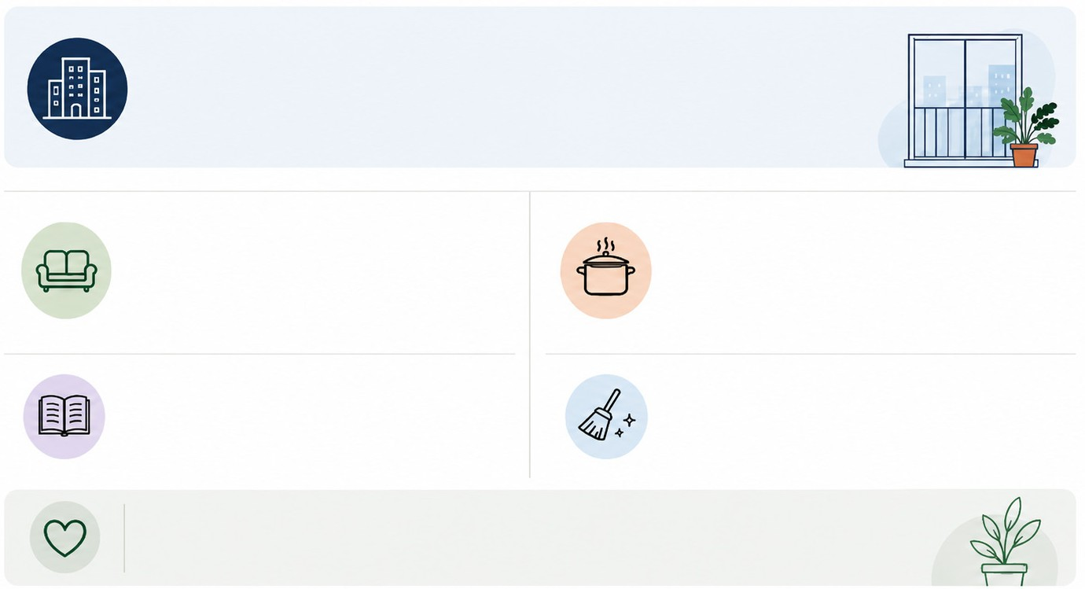
Hi! I’m Melis, and I live in a block of flats near the city centre. Our flat is not very large, but it is comfortable and bright. We have two bedrooms, a sitting room, a kitchen, a bathroom, and a small balcony.

Activities at home
- .....................................
- .....................................

My favourite place is the sitting room because there is a soft sofa, two cushions, a coffee table, and a colourful rug.
At the moment, I am sitting on the balcony and reading a book.
My mother usually prepares dinner in the kitchen, and my brother washes the dishes after dinner.
My father is tidying up the sitting room because our neighbours are visiting us this evening.
Furniture
- .....................................
- .....................................
Parts of the house
- .....................................
- .....................................

I like our flat because our neighbourhood has everything we need.

1B. Read the text again and answer the questions. (ENG.9.5.R2) (4x2=8)
- Where does Melis live? ........................................................................................................
- What rooms are there in her flat? .........................................................................................
- What does her brother do after dinner? ...............................................................................
- What is Melis doing now? .....................................................................................................

1C. Complete the sentences using the correct form of the verbs in brackets. (ENG.9.5.G1) (3x2=6)
- Melis (live) in a block of flats near the city centre.
- At the moment, Melis (sit) on the balcony.
- The sitting room (have) got a soft sofa and a colourful rug.

- Look at the festival card and write four sentences about the event. (ENG.9.6.W3) (4x5=20)
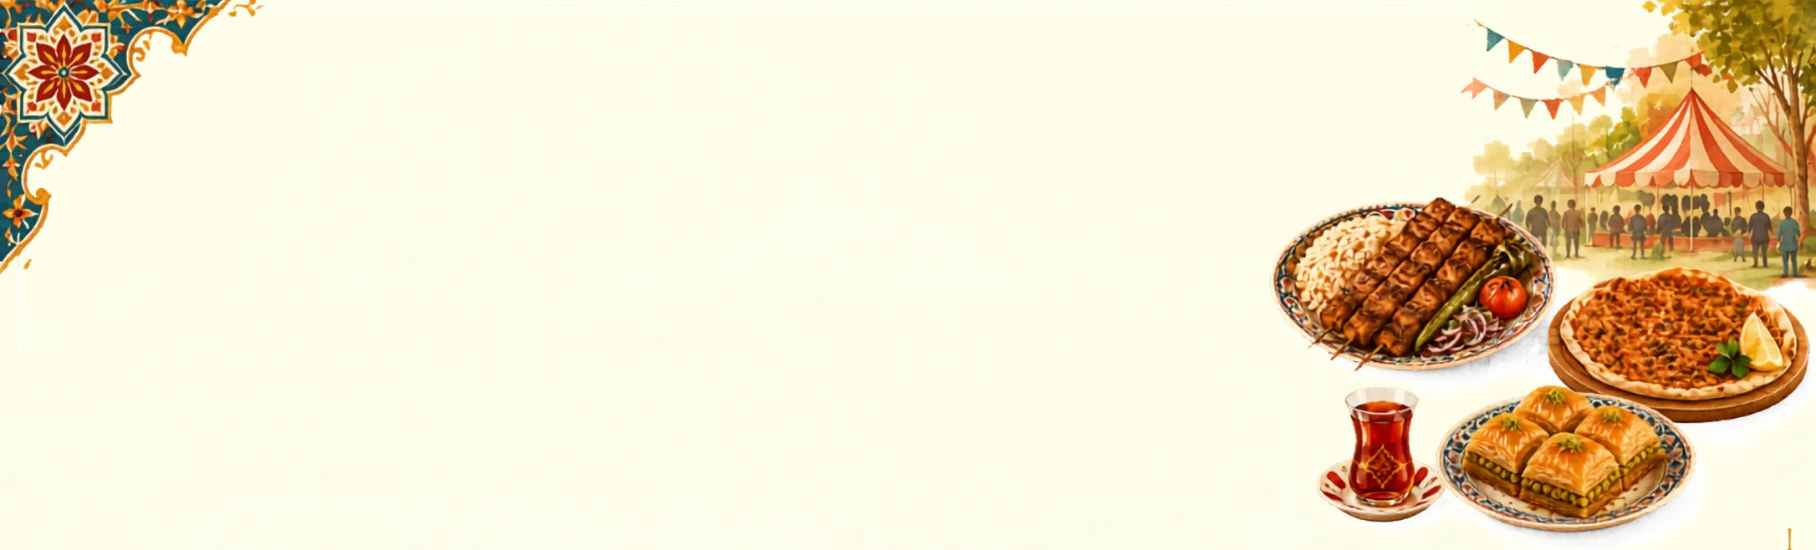

Event: Turkish Food Festival
City: London Place: Central Park
Time: Every summer
Food: kebab, lahmacun, baklava Activities now: watching cooking shows, tasting dishes, taking photos
  - ........................................................................................................

  - ........................................................................................................

  - ........................................................................................................

  - ........................................................................................................

- Read the text and answer the questions. (ENG.9.7.R3) (4x5=20)

Cheetahs are the fastest animals on land. They live in grasslands and deserts. In the past, there was a lot of space for them to run and hunt. Today, their population is decreasing. Farmers sometimes hunt them because they want to protect their farm animals. Also, they are losing their natural habitats. Cheetahs need safe areas to raise their babies. We should build shelters and protect the grasslands.
  - Where do cheetahs live?

...............................................................................
  - Why do farmers sometimes hunt cheetahs?
...............................................................................
  - Why is the cheetah population decreasing today?
Write two reasons.
...............................................................................
  - What should people do to protect cheetahs?
...............................................................................

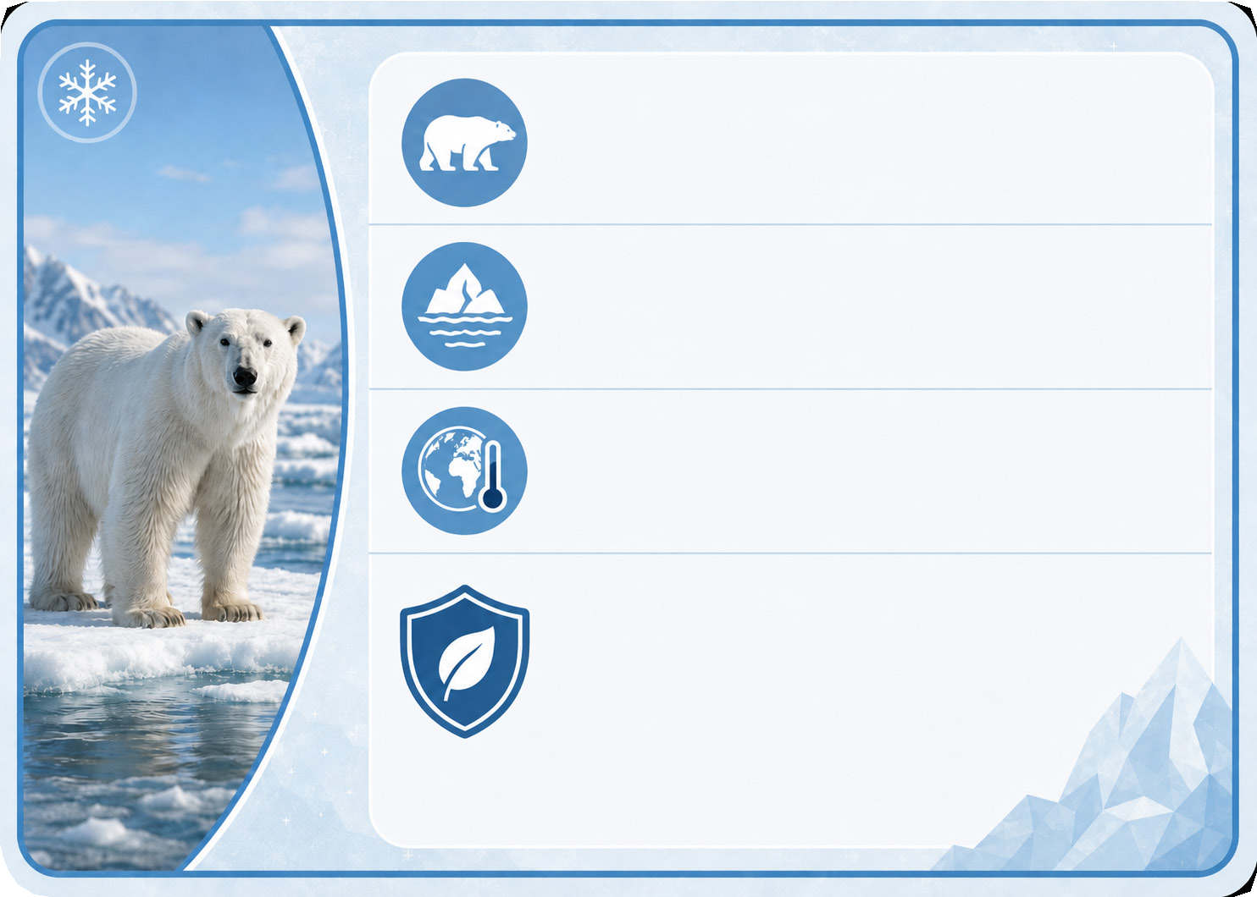
- Look at the card and write four sentences about the animal. (ENG.9.7.W4) (4x5=20)
Animal: Polar bear
Habitat: Arctic Sea ice

Cause of Endangerment:
Melting ice / climate change
Actions for Protection:
- Reduce air pollution
- Use less energy
- Protect icy habitats

  - ........................................................................................

  - ........................................................................................

  - ........................................................................................

  - ........................................................................................



- Complete the sentences using the correct form of the Simple Present Tense or the Simple Future Tense with the words in parentheses. (ENG.9.8.G1) (10x2=20)

The Future of Cinema

Today, most people (1) ................................. (go) to traditional cinemas to watch films. They
(2) .......................... (buy) their tickets online and (3) (sit) in dark rooms.
However, the cinema experience (4) (change) completely in the next twenty
years. Experts believe that we (5) (not need) traditional screens anymore.
Instead, virtual reality cinemas (6) (become) popular. When you enter the
cinema, a robotic assistant (7) (guide) you to your pod. Some people
(8) .................................. (not like) this idea because they (9) (prefer) the classic
style today. But I think everyone (10) (love) the new interactive movies soon.

