2025-2026 School 6th Grade 2nd Term 2nd Written Exam
Name – Surname: Class: Number:

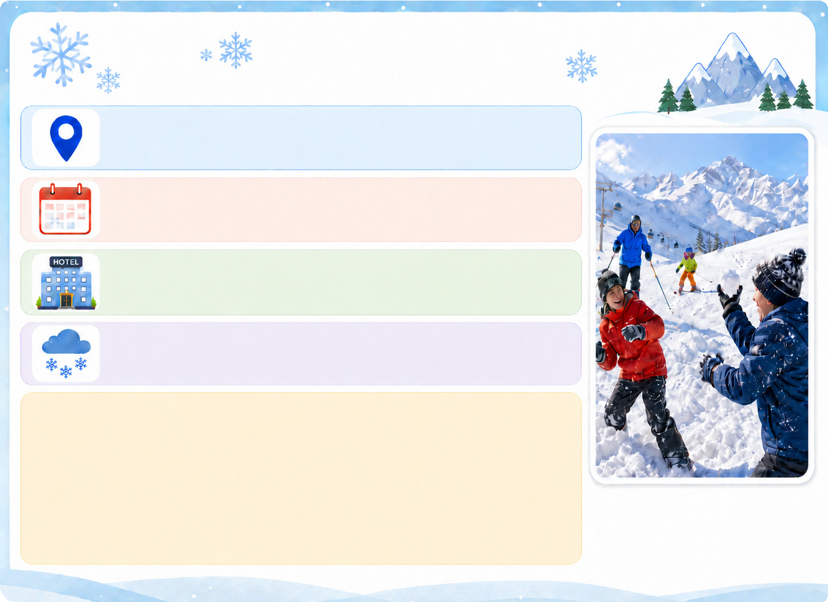
- Read the information about Tom’s holiday and answer the questions. (E6.7.R1.) (4x4=16)

Tom’s Winter Holiday

Holiday place: Mount Palandöken Date: Last January Accommodation: A hotel
Weather: Snowy and freezing
Activities: Tom had a snowball fight with his cousins. He learned skiing with his father. Tom liked his holiday because he loves snow and winter sports.

  - Where was Tom last January?

.................................................................................
  - Where did Tom stay?

.................................................................................
  - What was the weather like?

.................................................................................
  - Who did Tom have a snowball fight with?

..................................................................................

- Read the text and complete the table. (E6.8.R1.) (7x3=21)

Last Saturday, Arda visited a book fair in his town. He went there with his sister. First, they looked for children’s authors. Then, Arda bought an adventure novel, and his sister bought a poetry book. At three
o’clock, they listened to a funny story near the main stage. It was an exciting day.

Place: 1. ......................................................................

Date: 2. .......................................................................

Person with him: 3. ...................................................

Arda bought: 4. .........................................................

His sister bought: 5. .................................................

Activity at three o’clock: 6. ......................................

Feeling about the day: 7. ..........................................

- Read the text and complete the lists. (E6.9.R1.) (6x3=18)

Green Town has some environmental problems. The park is dirty, and there is rubbish near the lake. Some people use plastic bags and throw bottles around. There is also air pollution because many people drive their own cars. People should use recycling bins and cloth bags. They shouldn’t throw rubbish around. They can walk, cycle or use public transportation. Students can start a clean-up campaign. Green Town can be clean again.
A. Write three problems in the town:
B. Write three solutions for the town:
1.
1.
2.
2.
3.
3.

- Look at the pictures and write five sentences about where Miaw was yesterday. Use the prepositions given. (E6.8.W2.) (5x5=25)






1
2
3

- in – on – behind
- in front of – next to



  - .......................................................................................................
4
5

  - .......................................................................................................

  - .......................................................................................................

  - .......................................................................................................

  - .......................................................................................................

- Read the text and answer the questions. (E6.9.R2.) (4x5=20)
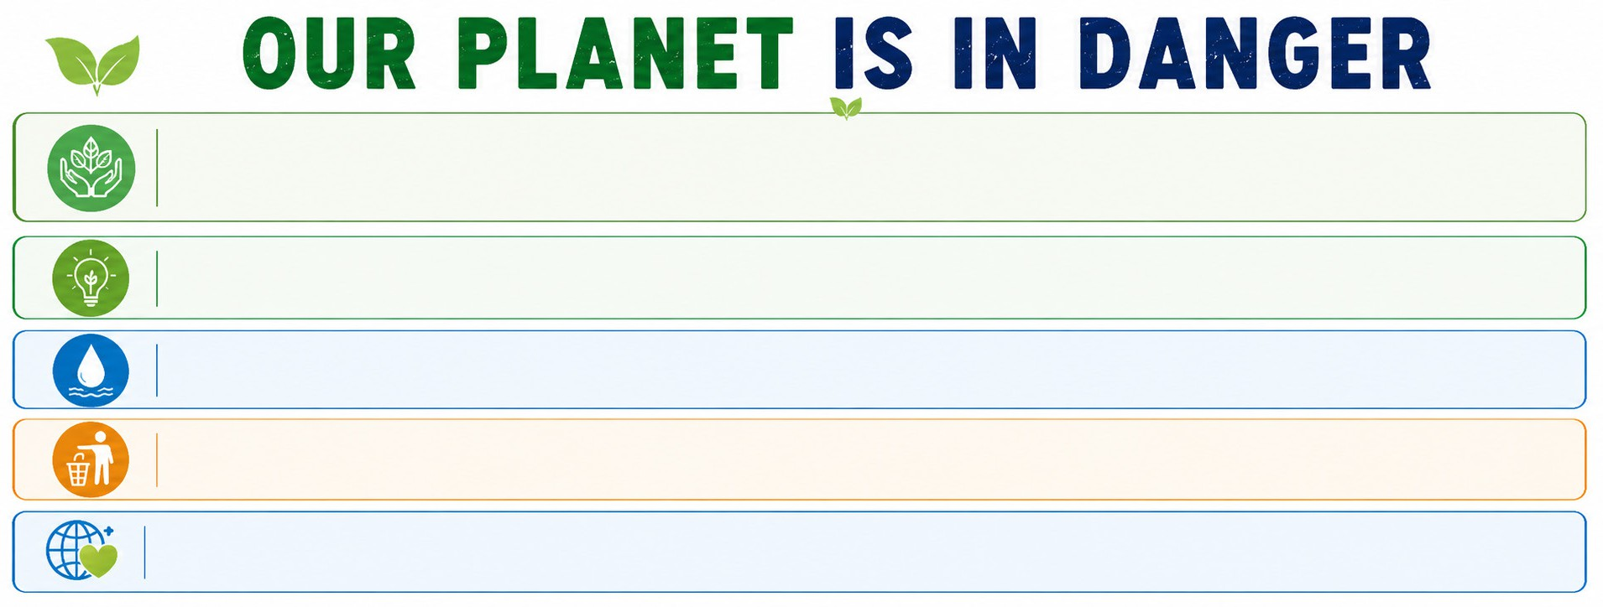

Today, we must learn how to reduce pollution. Please read and follow the instructions below carefully. Small actions can save our planet.

Save Energy: Turn off the TV when you are not watching it. You should unplug the chargers.

Save Water: Do not take long showers. Turn off the tap while brushing your teeth.

Keep it Clean: Pick up your rubbish. Do not litter in the parks or on streets.

Follow these steps every day because protecting our environment is very important.
- What should we do to save energy?

.............................................................................................................
- What should we do to keep parks and streets clean?

.............................................................................................................
- What shouldn’t we do to save water?

.............................................................................................................
- Why should we follow these steps every day?

.............................................................................................................

