2025-2026 School 6th Grade 2nd Term 2nd Written Exam
Name – Surname: Class: Number:

- Read the text and complete the ID card. (E6.6.R1.) (5x3=15)


Thomas Brown was born in London on November 12, 1985. He is a cook. He works at a small restaurant in the city centre. He can cook delicious French dishes. He starts work at 10 a.m. and finishes at 7 p.m. He thinks his job is difficult but exciting.
Name: 1. ................................................

Date of birth: 2. ....................................

Place of birth: 3. ...................................

Occupation: 4. ......................................

Workplace: 5. .......................................

- Read the author profile and answer the questions. (E6.8.R1.) (5x4=20)

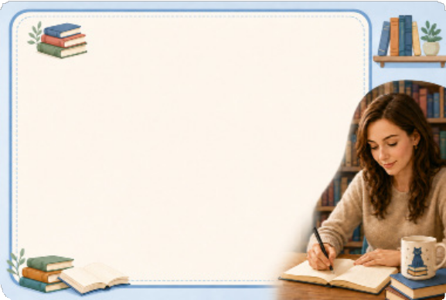
  - When was Clara Bell born?

Author Profile: Clara Bell
Clara Bell was born in 1980. She loved stories when she was a child. She wrote her first short story in 1990. It was about a lost cat in a library. Clara studied literature at university. Now, she is a famous writer. Children love her “Magic Bookshelf” series because the characters
are funny and brave.
.............................................................................
  - What did she love when she was a child?
.............................................................................
  - When did she write her first short story?
.............................................................................
  - What was her first story about?
.............................................................................
  - Why do children love her book series?
.............................................................................

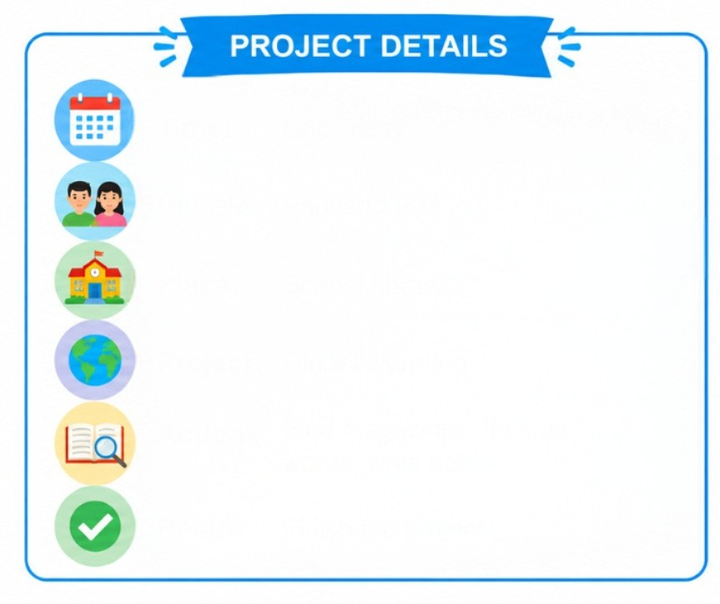
- Read the notes and write four sentences about Paul and Rita. (E6.8.W1.) (4x5=20)

Time: Last Friday People: Paul and Rita Place: School library Project: Global warming
Actions: Find magazines, look up words, write notes
Result: Finish the project

  - .......................................................................................................

  - .......................................................................................................

  - .......................................................................................................

  - .......................................................................................................

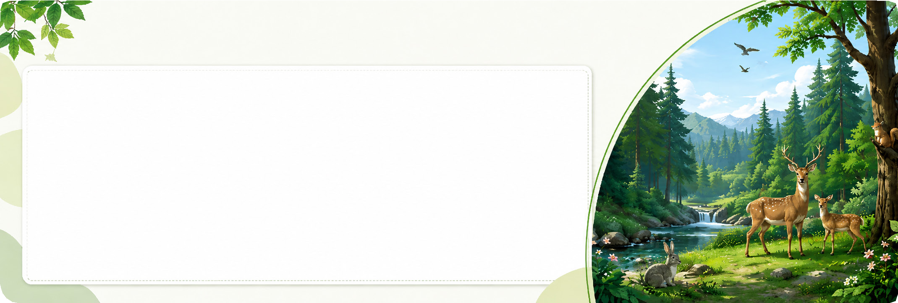
- Read the text and answer the questions. (E6.9.R1.) (5x4=20)
Protecting Forests

Forests are very important for our planet. Trees produce oxygen, and many animals live in forests. Some people cut down trees to build houses and make furniture and paper. This is harmful for nature. We should protect forests. We should plant new trees every year. We should reduce, reuse and recycle paper. We shouldn’t make a fire in the forest. We shouldn’t disturb animals. Forests are home to animals, so we should keep them safe.

- Why are forests important? ...................................................................................................

- What do trees produce? ........................................................................................................

- Why do some people cut down trees? ..................................................................................

- What should we plant every year? ........................................................................................

- Why should we keep forests safe? .......................................................................................

- Imagine you are preparing a poster about saving the planet. Write 5 sentences for your poster using “should” or “shouldn’t” with the given phrases. (E6.9.W1.) (5x5=25)
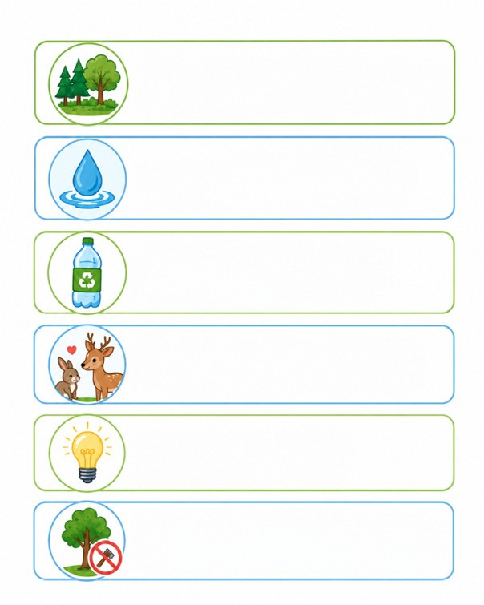
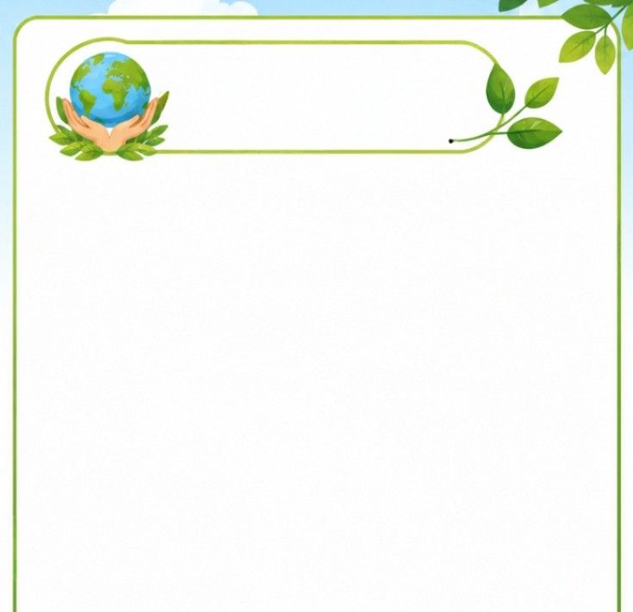

keep forests clean waste water recycle bottles harm animals save energy
cut down trees

PROTECT NATURE

- ......................................................................

- ......................................................................

- .......................................................................

- .......................................................................

- .......................................................................

