2025-2026 School 6th Grade 2nd Term 2nd Written Exam
Name – Surname: Class: Number:

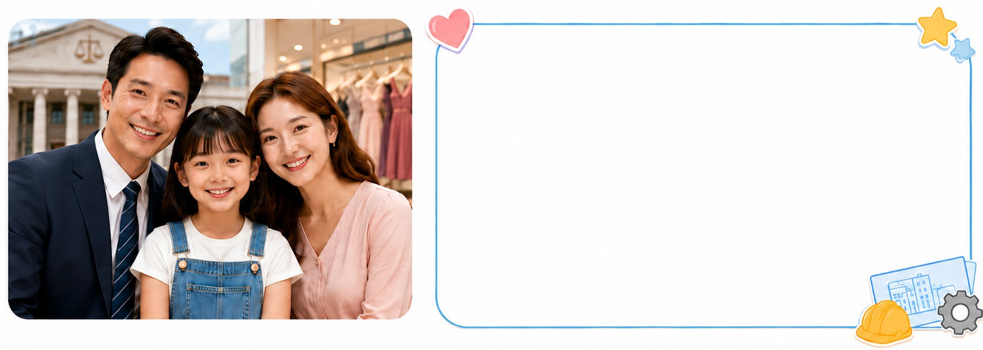
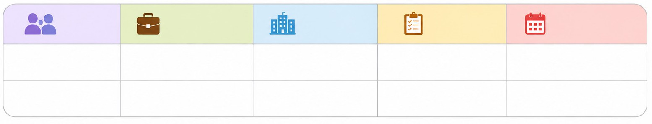
- Read the text and complete the table. (E6.6.R1.) (8x2=16)
Hi! I’m Lily. I want to tell you about my family. My father is a lawyer. He works at a courthouse and defends people. He was born on May 10,
1980. My mother is a saleswoman. She works at a clothes shop. She sells dresses. She was born on July 7, 1984. I like buildings and machines,
so I want to be an engineer in the future.
Person
Occupation
Workplace
Duty
Date of birth
Father
1.
2.
3.
4.
Mother
5.
6.
7.
8.

- Read the dialogue and answer the questions. (E6.8.R1.) (5x4=20)

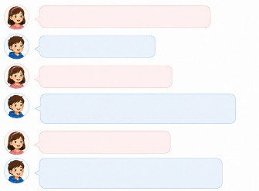
  - Where was Tom yesterday?
Where were you yesterday, Tom?
I was at the library.
What did you do there?

I looked for information about animals. I found a great magazine and borrowed a novel.

Did you read the novel?

No, I didn’t. I put it in my schoolbag. I want to read it tonight.
............................................................................
  - What did Tom look for?
............................................................................
  - What did Tom find?
............................................................................
  - What did Tom borrow?
............................................................................
  - Where did Tom put the novel?
............................................................................

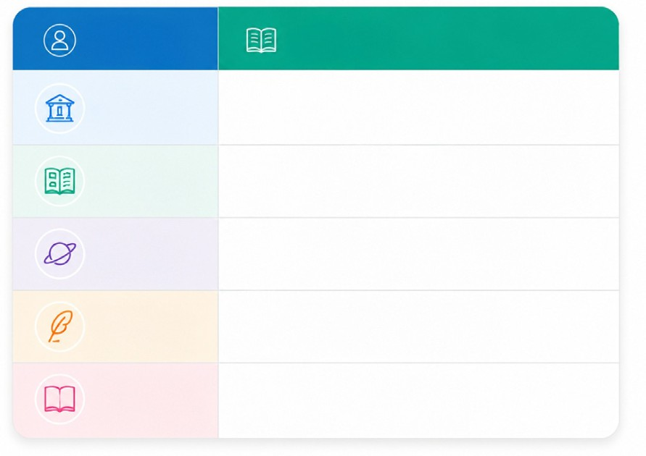
- Look at the table and write five sentences about the activities they did last Saturday. (E6.8.W1.) (5x4=20)
Name
Activity
John
borrow a poetry book
Sharon find a book about planets
Luke
go to the library
Mary
read a poem
Lily
write a short story

  - .......................................................................................................

  - .......................................................................................................

  - .......................................................................................................

  - .......................................................................................................

  - .......................................................................................................

- Read the dialogue and answer the questions. (E6.9.R1.) (4x4=16)

Host: Welcome to Green Talk. Today, our guest is Dr. Green.
Dr. Green: Hello, everyone.
Host: What is a big environmental problem?
Dr. Green: Air pollution is a big problem in many cities.
Host: What should people do?
Dr. Green: They shouldn’t use private cars all the time. They can walk, cycle or use public transportation.
Host: What about land pollution?
Dr. Green: People shouldn’t throw rubbish around. They should use recycling bins.
Host: Thank you for your advice.

- What is the name of the programme? .................................................................................................................
- What can people do to reduce air pollution? .......................................................................................................
- What should people use for their rubbish? ..........................................................................................................
- What shouldn’t people do to keep the land clean? .............................................................................................

- Read the speech bubbles and write the names under the correct pictures. (E6.9.R1.) (4x3=12)
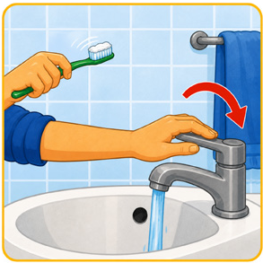
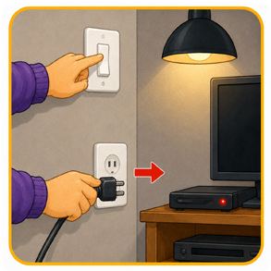
  - ..................... 2. .....................
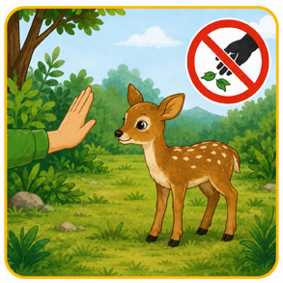
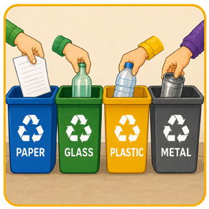
3. ..................... 4. .....................

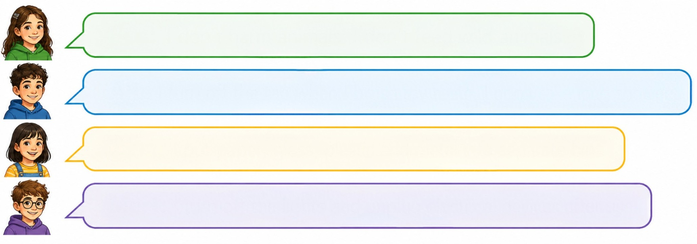
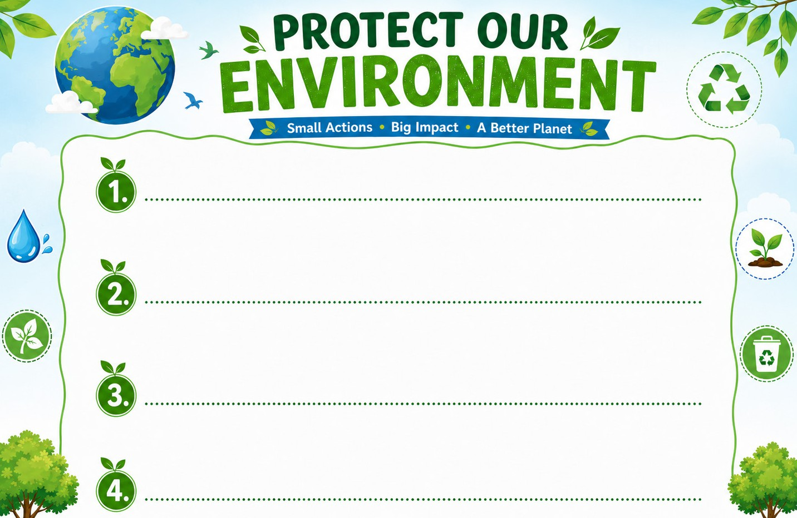
- Imagine you are preparing a poster about saving the planet. Write 4 sentences for your poster using “should” or “shouldn’t” with the given phrases. (E6.9.W1.) (4x4=16)
Ece: I don’t harm animals. I don’t feed wild animals.

Ali: I turn off the tap when I brush my teeth. I don’t take long showers.

Elif: I put paper, glass, plastic and metal into separate bins.

Mert: I turn off the lights and unplug electrical devices after use.

- plant trees

- pollute the air

- use plastic bags

- save water

- recycle paper

- drive private cars

